Test Case: runTestMultipleTimes
Step 1 - Enter username and password and click to button Enter : Credentials Entered
Image file-name: QC_Testing-runTestMultipleTimes-nov. 20 2025, 02 20 37 p. m.

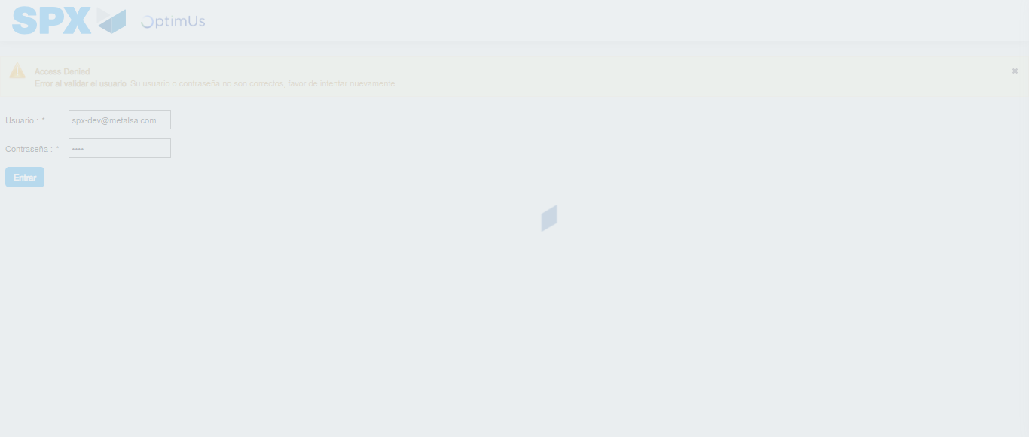Image file-name: QC_Testing-runTestMultipleTimes-nov. 20 2025, 02 20 38 p. m.

Step 2 - Select to UEN and Access to Administrador Roles Menu: UEN Correctly selected and Correct access
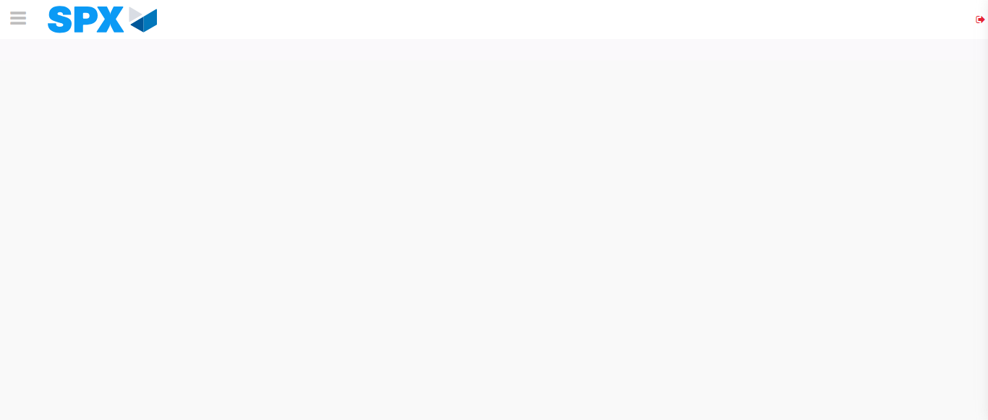Image file-name: QC_Testing-runTestMultipleTimes-nov. 20 2025, 02 20 47 p. m.

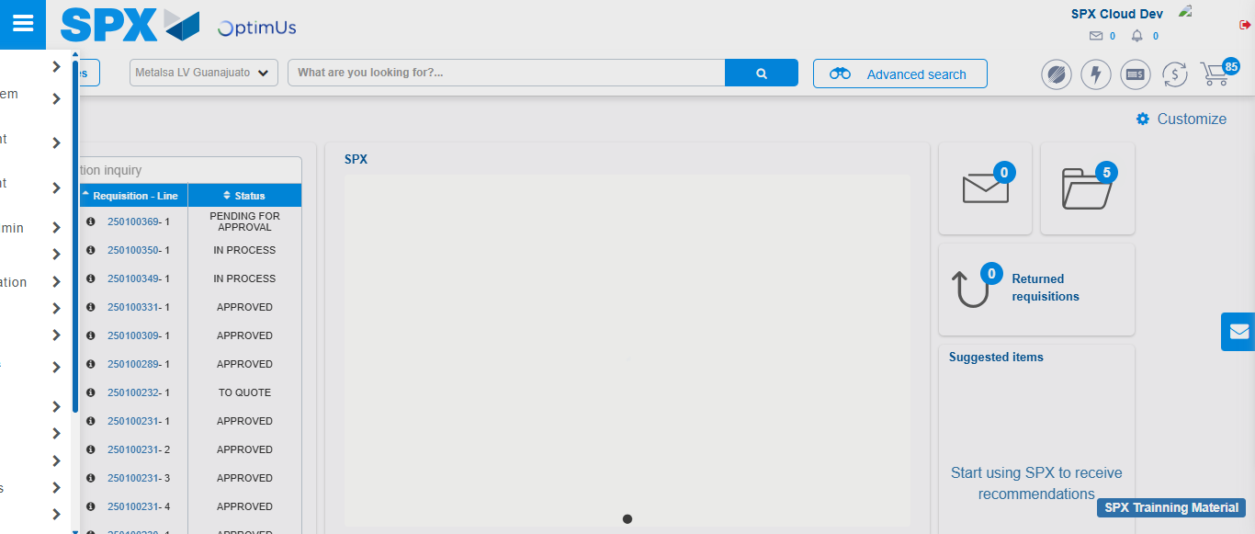Image file-name: QC_Testing-runTestMultipleTimes-nov. 20 2025, 02 20 48 p. m.

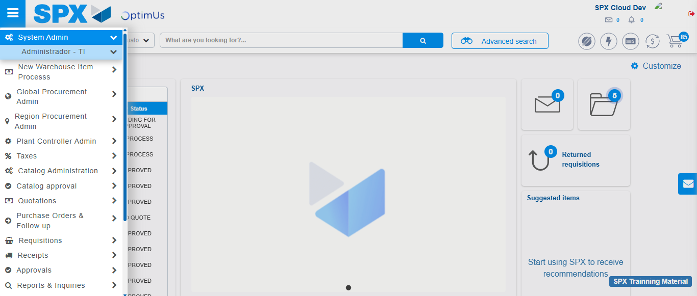Image file-name: QC_Testing-runTestMultipleTimes-nov. 20 2025, 02 20 49 p. m.

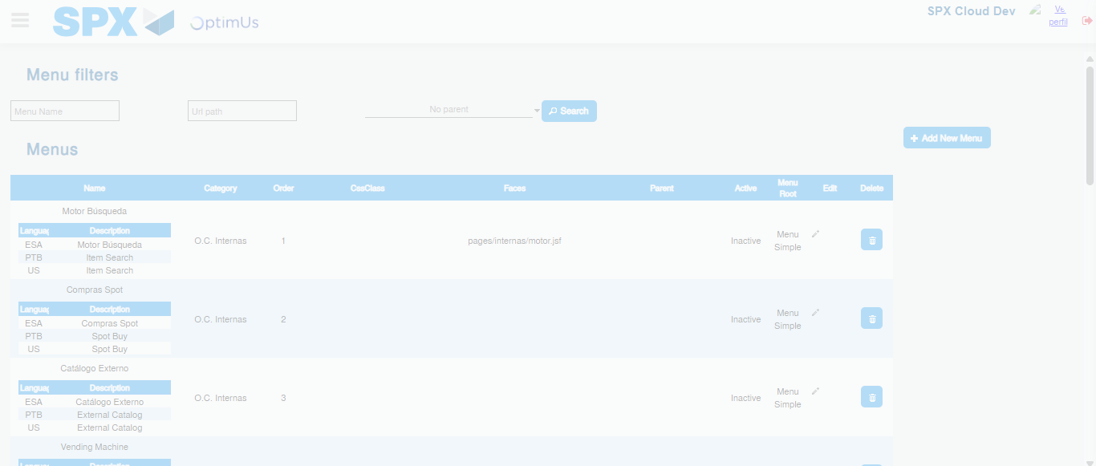Image file-name: QC_Testing-runTestMultipleTimes-nov. 20 2025, 02 20 52 p. m.

Step 3 - Add new menu and edit fields: New menu successfully registered
Image file-name: QC_Testing-runTestMultipleTimes-nov. 20 2025, 02 20 52 p. m.

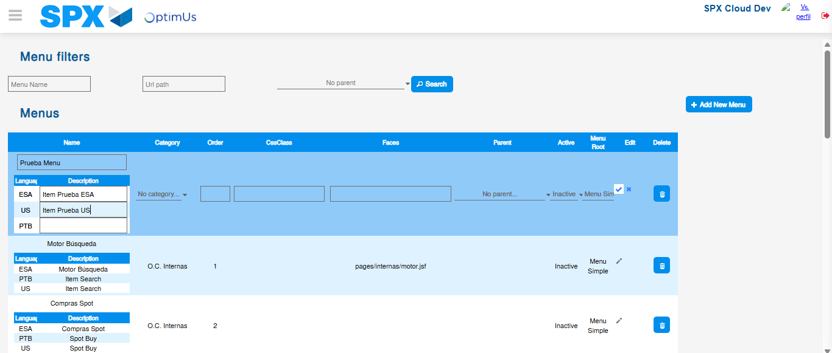Image file-name: QC_Testing-runTestMultipleTimes-nov. 20 2025, 02 20 56 p. m.

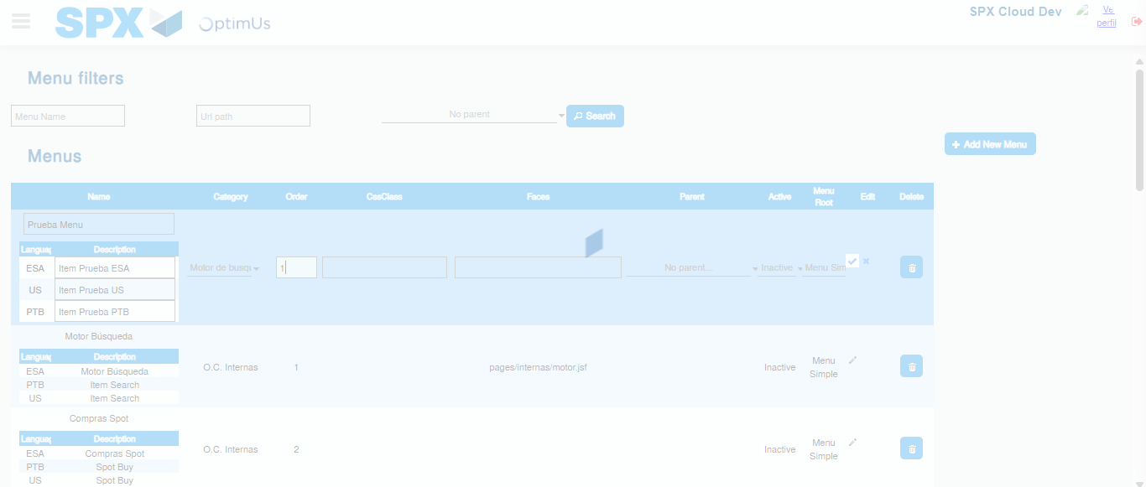Image file-name: QC_Testing-runTestMultipleTimes-nov. 20 2025, 02 20 57 p. m.

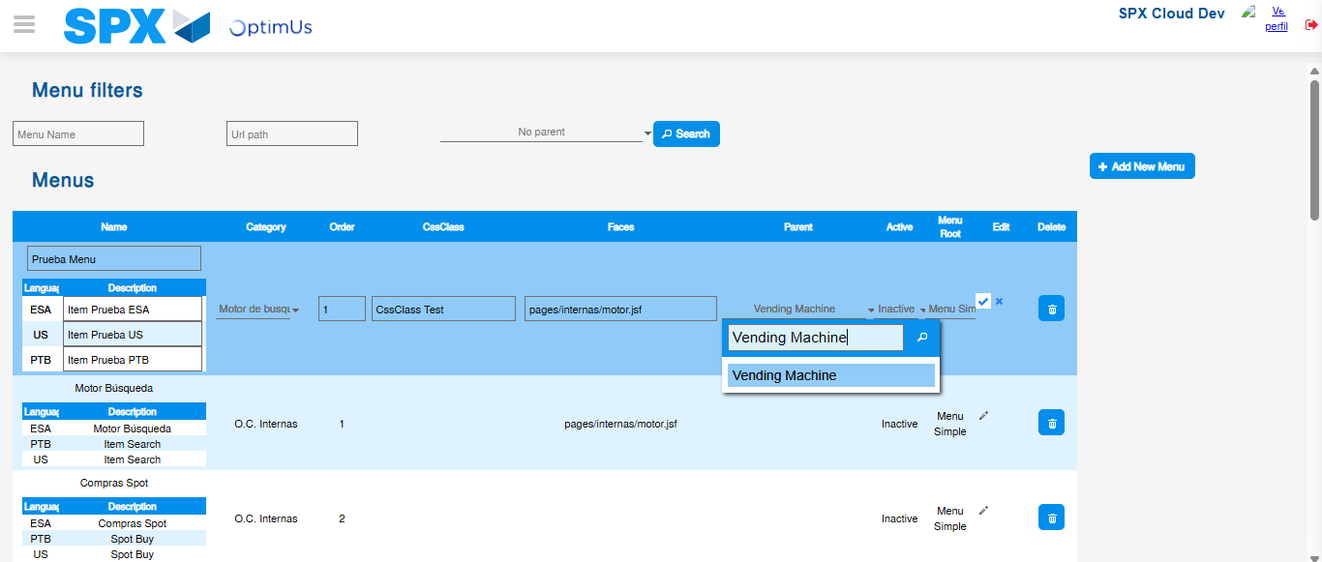Image file-name: QC_Testing-runTestMultipleTimes-nov. 20 2025, 02 20 58 p. m.

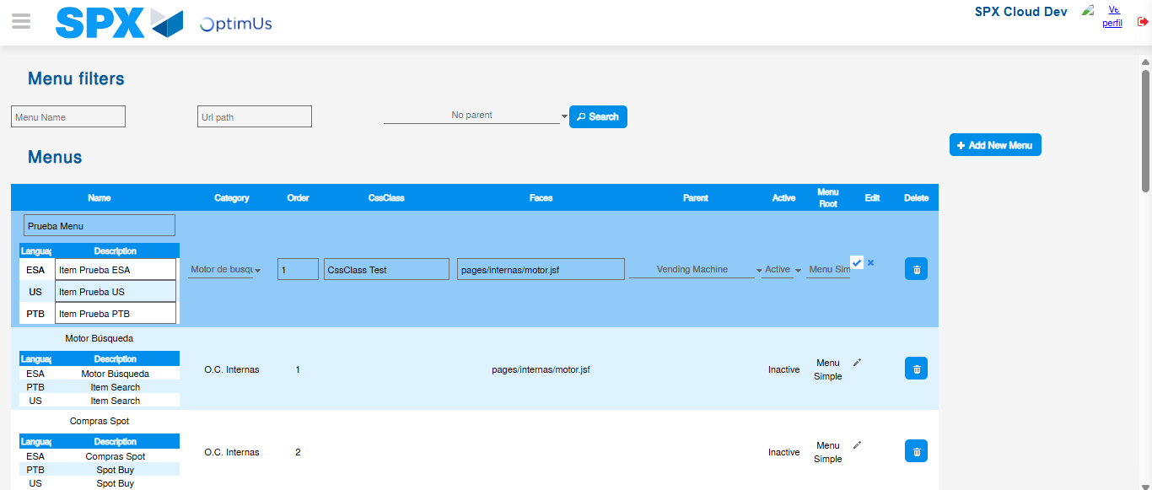Image file-name: QC_Testing-runTestMultipleTimes-nov. 20 2025, 02 20 59 p. m.

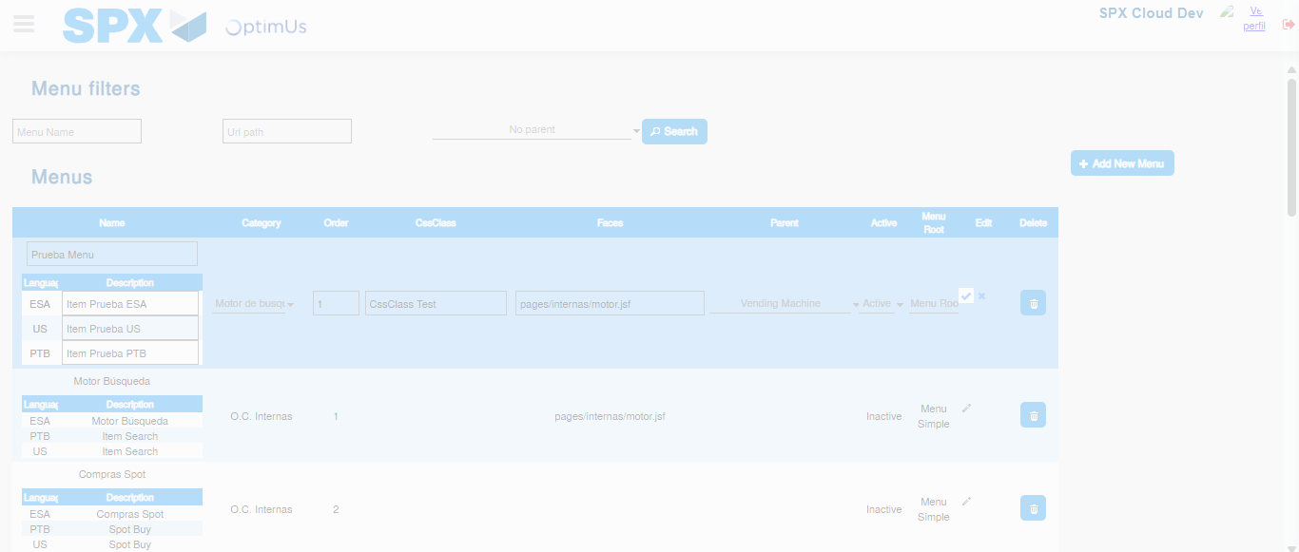Image file-name: QC_Testing-runTestMultipleTimes-nov. 20 2025, 02 21 00 p. m.

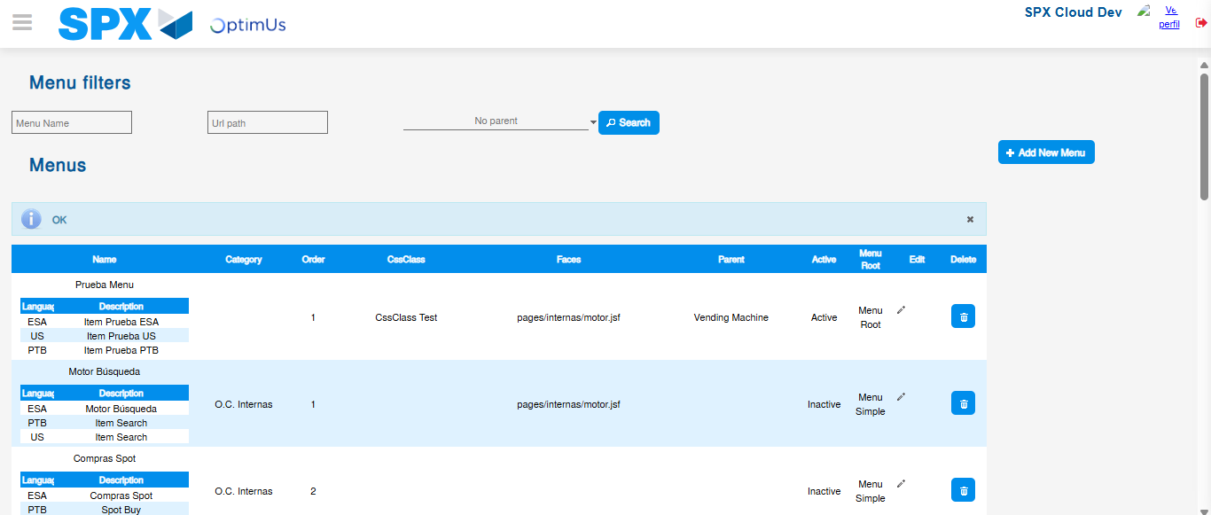Image file-name: QC_Testing-runTestMultipleTimes-nov. 20 2025, 02 21 04 p. m.

